**Argumentos de la función Arima**

SERIE ESTACIONARIA COM MEDIA CERO

> set.seed(444)

> y1 = arima.sim(model=list(ar=c(0.8,-0.4)), n=150, sd = sigma)

> autoplot(y1)

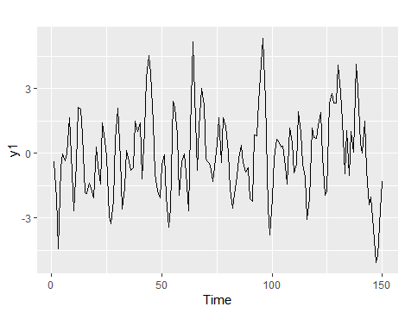

> Arima(y1, order = c(2,0,0), include.constant = TRUE)$coef

ar1 ar2 intercept

0.80790688 -0.35640157 -0.05247746

> Arima(y1, order = c(2,0,0), include.constant = FALSE)$coef

ar1 ar2

0.8083604 -0.3565131

> Arima(y1, order = c(2,0,0), include.mean = TRUE)$coef

ar1 ar2 intercept

0.80790688 -0.35640157 -0.05247746

> Arima(y1, order = c(2,0,0), include.mean = FALSE)$coef

ar1 ar2

0.8083604 -0.3565131

> Arima(y1, order = c(2,0,0), include.drift = TRUE)$coef

ar1 ar2 intercept drift

0.80639204 -0.35841117 -0.27862564 0.00299687

> Arima(y1, order = c(2,0,0), include.drift = FALSE)$coef

ar1 ar2 intercept

0.80790688 -0.35640157 -0.05247746

SERIE ESTACIONARIA COM MEDIA DISTINTA DE CERO

> set.seed(445)

> y2 = 10 + arima.sim(model=list(ar=c(0.8,-0.4)), n=150, sd = sigma)

> autoplot(y2)

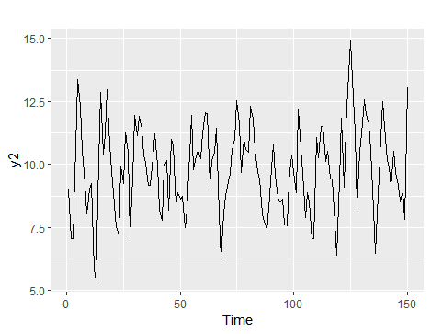

> Arima(y2, order = c(2,0,0), include.constant = TRUE)$coef

ar1 ar2 intercept

0.7138171 -0.2921810 9.8672658

> Arima(y2, order = c(2,0,0), include.constant = FALSE)$coef

ar1 ar2

0.99031610 -0.00261148

> Arima(y2, order = c(2,0,0), include.mean = TRUE)$coef

ar1 ar2 intercept

0.7138171 -0.2921810 9.8672658

> Arima(y2, order = c(2,0,0), include.mean = FALSE)$coef

ar1 ar2

0.99031610 -0.00261148

> Arima(y2, order = c(2,0,0), include.drift = TRUE)$coef

ar1 ar2 intercept drift

0.71120324 -0.29438789 9.55630153 0.00411581

> Arima(y2, order = c(2,0,0), include.drift = FALSE)$coef

ar1 ar2 intercept

0.7138171 -0.2921810 9.8672658

SERIE CON TENDENCIA ESTACIONARIA

> set.seed(222)

> y3 = 10 + arima.sim(model=list(ar=c(0.8,-0.4)), n=150, sd = sigma) + 1:150

> autoplot(y3)

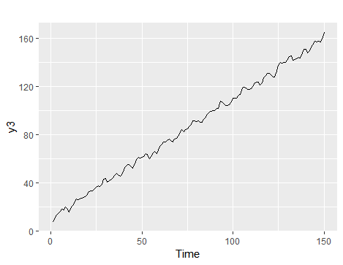

> Arima(y3, order = c(2,0,0), include.constant = TRUE)$coef

ar1 ar2 intercept

0.003740224 0.996258991 85.497274891

> Arima(y3, order = c(2,0,0), include.constant = FALSE)$coef

Error in stats::arima(x = x, order = order, seasonal = seasonal, include.mean = include.mean, :

non-stationary AR part from CSS

> Arima(y3, order = c(2,0,0), include.mean = TRUE)$coef

ar1 ar2 intercept

0.003740224 0.996258991 85.497274891

> Arima(y3, order = c(2,0,0), include.mean = FALSE)$coef

Error in stats::arima(x = x, order = order, seasonal = seasonal, include.mean = include.mean, :

non-stationary AR part from CSS

> Arima(y3, order = c(2,0,0), include.drift = TRUE)$coef

ar1 ar2 intercept drift

0.8900932 -0.5022110 9.9209806 1.0024536

> Arima(y3, order = c(2,0,0), include.drift = FALSE)$coef

ar1 ar2 intercept

0.003740224 0.996258991 85.497274891

SERIE NO ESTACIONARIA

> set.seed(321)

> y4 = arima.sim(model=list(order = c(2,1,0), ar=c(0.8,-0.4)), n=150, sd = sigma)

> autoplot(y4)

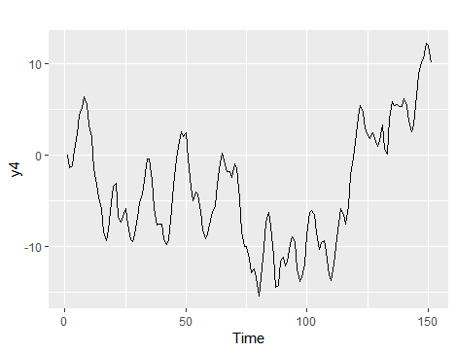

> Arima(y4, order = c(2,1,0), include.constant = TRUE)$coef

ar1 ar2 drift

0.7812815 -0.4077022 0.0543964

> Arima(y4, order = c(2,1,0), include.constant = FALSE)$coef

ar1 ar2

0.7819340 -0.4070671

> Arima(y4, order = c(2,1,0), include.mean = TRUE)$coef

ar1 ar2

0.7819340 -0.4070671

> Arima(y4, order = c(2,1,0), include.mean = FALSE)$coef

ar1 ar2

0.7819340 -0.4070671

> Arima(y4, order = c(2,1,0), include.drift = TRUE)$coef

ar1 ar2 drift

0.7812815 -0.4077022 0.0543964

> Arima(y4, order = c(2,1,0), include.drift = FALSE)$coef

ar1 ar2

0.7819340 -0.4070671

SERIE NO ESTACIONARIA

> set.seed(502)

> y5 = 15 + arima.sim(model=list(order = c(2,1,0), ar=c(0.8,-0.4)), n=150, sd = sigma)

> autoplot(y5)

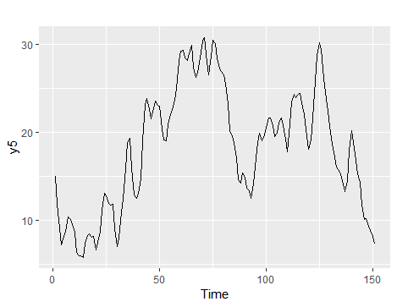

> Arima(y5, order = c(2,1,0), include.constant = TRUE)$coef

ar1 ar2 drift

0.81918928 -0.41240246 -0.05374074

> Arima(y5, order = c(2,1,0), include.constant = FALSE)$coef

ar1 ar2

0.8195883 -0.4126031

> Arima(y5, order = c(2,1,0), include.mean = TRUE)$coef

ar1 ar2

0.8195883 -0.4126031

> Arima(y5, order = c(2,1,0), include.mean = FALSE)$coef

ar1 ar2

0.8195883 -0.4126031

> Arima(y5, order = c(2,1,0), include.drift = TRUE)$coef

ar1 ar2 drift

0.81918928 -0.41240246 -0.05374074

> Arima(y5, order = c(2,1,0), include.drift = FALSE)$coef

ar1 ar2

0.8195883 -0.4126031

SERIE NO ESTACIONARIA

> set.seed(3214)

> y6 = 15 + arima.sim(model=list(order = c(2,2,0), ar=c(0.8,-0.4)), n=150, sd = sigma)

> autoplot(y6)

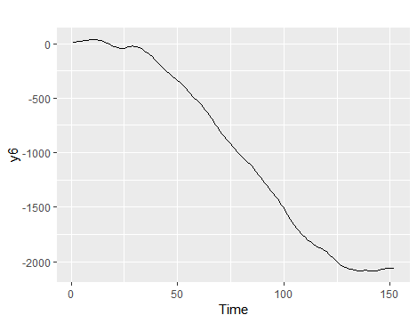

> Arima(y6, order = c(2,2,0), include.constant = TRUE)$coef

ar1 ar2

0.8328218 -0.3408569

> Arima(y6, order = c(2,2,0), include.constant = FALSE)$coef

ar1 ar2

0.8328218 -0.3408569

> Arima(y6, order = c(2,2,0), include.mean = TRUE)$coef

ar1 ar2

0.8328218 -0.3408569

> Arima(y6, order = c(2,2,0), include.mean = FALSE)$coef

ar1 ar2

0.8328218 -0.3408569

> Arima(y6, order = c(2,2,0), include.drift = TRUE)$coef

ar1 ar2

0.8328218 -0.3408569

Warning message:

In Arima(y6, order = c(2, 2, 0), include.drift = TRUE) :

No drift term fitted as the order of difference is 2 or more.

> Arima(y6, order = c(2,2,0), include.drift = FALSE)$coef

ar1 ar2

0.8328218 -0.3408569